**Squaring the circle**

In the diagram below the circle and square have the same centre and the same perimeter.

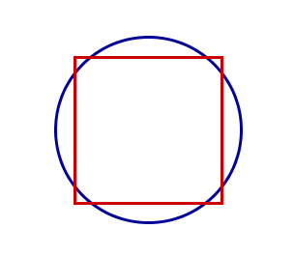

What fraction of the area of square lies outside the circle?

What fraction of the area of circle lies outside the square?